1

Code:

libname college 'C:\Users\Samil\Desktop\Sem 1\Stats for programming\SAS 9.4';

**DATA** PATIENTS;

INPUT @**1** ID $3.

@**4** DATE MMDDYY8.

@**12** HR **3.**

@**15** SBP **3.**

@**18** DBP **3.**

@**21** DX **3.**

@**24** DOCFEE **4.**

@**28** LABFEE **4.**;

FORMAT DATE MMDDYY10.;

DATALINES;

0071021198307012008001400400150

0071201198307213009002000500200

0090903198306611007013700300000

0050705198307414008201300900000

0050115198208018009601402001500

0050618198207017008401400800400

0050703198306414008401400800200

;

**run**;

/*proc print data=PATIENTS;

run;*/

**proc** **sort** data=PATIENTS

out=PATIENTS1;

by ID Date;

**run**;

/*proc print data=PATIENTS1;

run;*/

**data** PATIENTS2;

set PATIENTS1;

by ID;

if First.ID then delete;

**run**;

/*proc print data=PATIENTS2;

run;*/

title 'Mean for the ID';

**proc** **means** data=PATIENTS2 mean;

class ID;

var HR SBP DBP;

output out = my_summary

mean=HR SBP DBP;

**run**;

title;

Log File:

285 DATA PATIENTS;

286 INPUT @1 ID $3.

287 @4 DATE MMDDYY8.

288 @12 HR 3.

289 @15 SBP 3.

290 @18 DBP 3.

291 @21 DX 3.

292 @24 DOCFEE 4.

293 @28 LABFEE 4.;

294 FORMAT DATE MMDDYY10.;

295 DATALINES;

NOTE: The data set WORK.PATIENTS has 7 observations and 8 variables.

NOTE: DATA statement used (Total process time):

real time 0.05 seconds

cpu time 0.06 seconds

303 ;

304 run;

305

306 /*proc print data=PATIENTS;

307 run;*/

308

309 proc sort data=PATIENTS

310 out=PATIENTS1;

311 by ID Date;

312 run;

NOTE: There were 7 observations read from the data set WORK.PATIENTS.

NOTE: The data set WORK.PATIENTS1 has 7 observations and 8 variables.

NOTE: PROCEDURE SORT used (Total process time):

real time 0.05 seconds

cpu time 0.01 seconds

313

314 /*proc print data=PATIENTS1;

315 run;*/

316

317 data PATIENTS2;

318 set PATIENTS1;

319 by ID;

320 if First.ID then delete;

321 run;

NOTE: There were 7 observations read from the data set WORK.PATIENTS1.

NOTE: The data set WORK.PATIENTS2 has 4 observations and 8 variables.

NOTE: DATA statement used (Total process time):

real time 0.04 seconds

cpu time 0.03 seconds

322

323 /*proc print data=PATIENTS2;

324 run;*/

325

326 title 'Mean for the ID';

327

328 proc means data=PATIENTS2 mean;

329 class ID;

330 var HR SBP DBP;

331 output out = my_summary

332 mean=HR SBP DBP;

333 run;

NOTE: There were 4 observations read from the data set WORK.PATIENTS2.

NOTE: The data set WORK.MY_SUMMARY has 3 observations and 6 variables.

NOTE: PROCEDURE MEANS used (Total process time):

real time 0.26 seconds

cpu time 0.04 seconds

334

335 title;

Output:

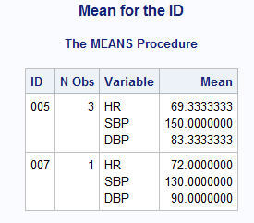

2

Code:

**proc** **sort** data=PATIENTS

out=PATIENTS1;

by ID Date;

**run**;

**proc** **sql**;

create table Patients3 as

select * from PATIENTS group by ID having count(ID)>**1**;

**quit**;

/*proc print data=Patients3;

run;*/

**proc** **means** data=Patients3 noprint;

by ID;

*var ID;

output out = PAT_Mean

mean=/autoname;

**run**;

Title 'Patients Mean';

**proc** **print** data=PAT_Mean;

**run**;

Title;

Log File:

371 proc sort data=PATIENTS

372 out=PATIENTS1;

373 by ID Date;

374 run;

NOTE: There were 7 observations read from the data set WORK.PATIENTS.

NOTE: The data set WORK.PATIENTS1 has 7 observations and 8 variables.

NOTE: PROCEDURE SORT used (Total process time):

real time 0.09 seconds

cpu time 0.03 seconds

375

376 proc sql;

377 create table Patients3 as

378 select * from PATIENTS group by ID having count(ID)>1;

NOTE: The query requires remerging summary statistics back with the original data.

NOTE: Table WORK.PATIENTS3 created, with 6 rows and 8 columns.

379 quit;

NOTE: PROCEDURE SQL used (Total process time):

real time 0.09 seconds

cpu time 0.01 seconds

380

381 /*proc print data=Patients3;

382 run;*/

383

384 proc means data=Patients3 noprint;

385 by ID;

386 *var ID;

387 output out = PAT_Mean

388 mean=/autoname;

389 run;

NOTE: There were 6 observations read from the data set WORK.PATIENTS3.

NOTE: The data set WORK.PAT_MEAN has 2 observations and 10 variables.

NOTE: PROCEDURE MEANS used (Total process time):

real time 0.11 seconds

cpu time 0.03 seconds

390

391 Title 'Patients Mean';

392

393 proc print data=PAT_Mean;

394 run;

NOTE: There were 2 observations read from the data set WORK.PAT_MEAN.

NOTE: PROCEDURE PRINT used (Total process time):

real time 0.18 seconds

cpu time 0.04 seconds

395

396 Title;

Output:

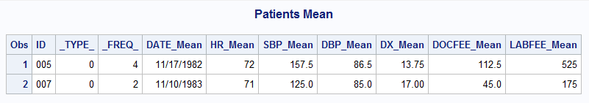

3

Code:

**DATA** BLOOD;

LENGTH GROUP $ **1**;

INPUT ID GROUP $ TIME WBC RBC @@;

DATALINES;

1 A 1 8000 4.5 1 A 2 8200 4.8 1 A 3 8400 5.2

1 A 4 8300 5.3 1 A 5 8400 5.5

2 A 1 7800 4.9 2 A 2 7900 5.0

3 B 1 8200 5.4 3 B 2 8300 5.4 3 B 3 8300 5.2

3 B 4 8200 4.9 3 B 5 8300 5.0

4 B 1 8600 5.5

5 A 1 7900 5.2 5 A 2 8000 5.2 5 A 3 8200 5.4

5 A 4 8400 5.5

;

**run**;

/*proc print data=BLOOD;

run;*/

**proc** **means** data=blood mean nway noprint;

class ID Group;

var RBC WBC;

output out = by_group

mean = M_RBC M_WBC;

**run**;

/*

proc print data=by_group;

run;*/

**data** blood_output;

set by_group;

where _Freq_>**2**;

keep ID Group M_RBC M_WBC;

**run**;

Title 'Blood Sample DATA';

**proc** **print** data=blood_output;

**run**;

Title;

Log File:

474 DATA BLOOD;

475 LENGTH GROUP $ 1;

476 INPUT ID GROUP $ TIME WBC RBC @@;

477 DATALINES;

NOTE: SAS went to a new line when INPUT statement reached past the end of a line.

NOTE: The data set WORK.BLOOD has 17 observations and 5 variables.

NOTE: DATA statement used (Total process time):

real time 0.04 seconds

cpu time 0.01 seconds

486 ;

487 run;

488

489 /*proc print data=BLOOD;

490 run;*/

491

492 proc means data=blood mean nway noprint;

493 class ID Group;

494 var RBC WBC;

495 output out = by_group

496 mean = M_RBC M_WBC;

497 run;

NOTE: There were 17 observations read from the data set WORK.BLOOD.

NOTE: The data set WORK.BY_GROUP has 5 observations and 6 variables.

NOTE: PROCEDURE MEANS used (Total process time):

real time 0.07 seconds

cpu time 0.06 seconds

498

499 /*

500 proc print data=by_group;

501 run;*/

502

503 data blood_output;

504 set by_group;

505 where _Freq_>2;

506 keep ID Group M_RBC M_WBC;

507 run;

NOTE: There were 3 observations read from the data set WORK.BY_GROUP.

WHERE _Freq_>2;

NOTE: The data set WORK.BLOOD_OUTPUT has 3 observations and 4 variables.

NOTE: DATA statement used (Total process time):

real time 0.02 seconds

cpu time 0.01 seconds

508

509 Title 'Blood Sample DATA';

510

511 proc print data=blood_output;

512 run;

NOTE: There were 3 observations read from the data set WORK.BLOOD_OUTPUT.

NOTE: PROCEDURE PRINT used (Total process time):

real time 0.10 seconds

cpu time 0.00 seconds

513

514 Title;

Output:

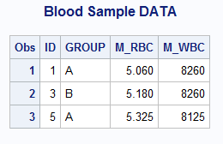

4

Code:

**proc** **means** data=blood mean std nway noprint;

class ID Group;

var RBC WBC;

output out = by_subject

mean = M_RBC M_WBC

std= SD_RBC SD_WBC;

**run**;

/*proc print data=by_subject;

run;*/

**data** blood_output_2;

set by_subject;

where _Freq_>**2**;

keep ID Group M_RBC M_WBC SD_RBC SD_WBC;

**run**;

Title 'Blood Sample DATA';

**proc** **print** data=blood_output_2;

**run**;

Title;

Log File:

534 proc means data=blood mean std nway noprint;

535 class ID Group;

536 var RBC WBC;

537 output out = by_subject

538 mean = M_RBC M_WBC

539 std= SD_RBC SD_WBC;

540 run;

NOTE: There were 17 observations read from the data set WORK.BLOOD.

NOTE: The data set WORK.BY_SUBJECT has 5 observations and 8 variables.

NOTE: PROCEDURE MEANS used (Total process time):

real time 0.06 seconds

cpu time 0.06 seconds

541

542 /*proc print data=by_subject;

543 run;*/

544

545 data blood_output_2;

546 set by_subject;

547 where _Freq_>2;

548 keep ID Group M_RBC M_WBC SD_RBC SD_WBC;

549 run;

NOTE: There were 3 observations read from the data set WORK.BY_SUBJECT.

WHERE _Freq_>2;

NOTE: The data set WORK.BLOOD_OUTPUT_2 has 3 observations and 6 variables.

NOTE: DATA statement used (Total process time):

real time 0.02 seconds

cpu time 0.01 seconds

550

551 Title 'Blood Sample DATA';

552

553 proc print data=blood_output_2;

554 run;

NOTE: There were 3 observations read from the data set WORK.BLOOD_OUTPUT_2.

NOTE: PROCEDURE PRINT used (Total process time):

real time 0.31 seconds

cpu time 0.01 seconds

555

556 Title;

Output:

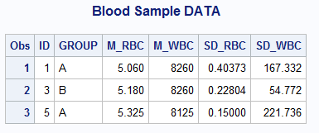

5

Code:

**DATA** LIVER;

INPUT SUBJ DOSE REACT LIVER_WT SPLEEN;

DATALINES;

1 1 5.4 10.2 8.9

2 1 5.9 9.8 7.3

3 1 4.8 12.2 9.1

4 1 6.9 11.8 8.8

5 1 15.8 10.9 9.0

6 2 4.9 13.8 6.6

7 2 5.0 12.0 7.9

8 2 6.7 10.5 8.0

9 2 18.2 11.9 6.9

10 2 5.5 9.9 9.1

;

**run**;

/*proc print data=LIVER;

run;*/

**proc** **sort** data=LIVER

out=my_liver;

by SUBJ;

**run**;

ods pdf file='c:\temp\sastest1.pdf' startpage=no notoc dpi=**300**;

*options orientation=landscape;

*ods graphics / reset=all height=4in width=7in;

ods trace on;

*ods layout start height=7.25in width=10.5in;

*ods region row=1 column=1;

Title 'Plots of Liver';

**proc** **univariate** data=LIVER normal plot;

var REACT LIVER_WT SPLEEN;

Histogram REACT LIVER_WT SPLEEN/ normal;

ods select Histogram plots;

**run**;

Title;

*ods layout end;

Title 'Plots of liver according to Dose';

**proc** **univariate** data=LIVER normal plot;

Class Dose;

var REACT LIVER_WT SPLEEN;

Histogram REACT LIVER_WT SPLEEN/ normal;

ods select Histogram plots;

**run**;

Title;

ods trace off;

ods pdf close;

Log File:

1132 DATA LIVER;

1133 INPUT SUBJ DOSE REACT LIVER_WT SPLEEN;

1134 DATALINES;

NOTE: The data set WORK.LIVER has 10 observations and 5 variables.

NOTE: DATA statement used (Total process time):

real time 0.01 seconds

cpu time 0.00 seconds

1145 ;

1146 run;

1147

1148 /*proc print data=LIVER;

1149 run;*/

1150

1151 proc sort data=LIVER

1152 out=my_liver;

1153 by SUBJ;

1154 run;

NOTE: There were 10 observations read from the data set WORK.LIVER.

NOTE: The data set WORK.MY_LIVER has 10 observations and 5 variables.

NOTE: PROCEDURE SORT used (Total process time):

real time 0.01 seconds

cpu time 0.00 seconds

1155 ods pdf file='c:\temp\sastest1.pdf' startpage=no notoc dpi=300;

NOTE: Writing ODS PDF output to DISK destination "c:\temp\sastest1.pdf", printer "PDF".

1156 *options orientation=landscape;

1157 *ods graphics / reset=all height=4in width=7in;

1158 ods trace on;

1159 *ods layout start height=7.25in width=10.5in;

1160 *ods region row=1 column=1;

1161 Title 'Plots of Liver';

1162 proc univariate data=LIVER normal plot;

1163 var REACT LIVER_WT SPLEEN;

1164 Histogram REACT LIVER_WT SPLEEN/ normal;

1165 ods select Histogram plots;

1166 run;

Output Added:

-------------

Name: Plots

Label: Plots for REACT

Template: base.univariate.Graphics.Plots

Path: Univariate.REACT.Plots

-------------

Output Added:

-------------

Name: Histogram

Label: Panel 1

Template: base.univariate.Graphics.Histogram

Path: Univariate.REACT.Histogram.Histogram

-------------

Output Added:

-------------

Name: Plots

Label: Plots for LIVER_WT

Template: base.univariate.Graphics.Plots

Path: Univariate.LIVER_WT.Plots

-------------

Output Added:

-------------

Name: Histogram

Label: Panel 1

Template: base.univariate.Graphics.Histogram

Path: Univariate.LIVER_WT.Histogram.Histogram

-------------

Output Added:

-------------

Name: Plots

Label: Plots for SPLEEN

Template: base.univariate.Graphics.Plots

Path: Univariate.SPLEEN.Plots

-------------

Output Added:

-------------

Name: Histogram

Label: Panel 1

Template: base.univariate.Graphics.Histogram

Path: Univariate.SPLEEN.Histogram.Histogram

-------------

NOTE: PROCEDURE UNIVARIATE used (Total process time):

real time 3.56 seconds

cpu time 1.10 seconds

1167 Title;

1168 *ods layout end;

1169

1170

1171 Title 'Plots of liver according to Dose';

1172 proc univariate data=LIVER normal plot;

1173 Class Dose;

1174 var REACT LIVER_WT SPLEEN;

1175 Histogram REACT LIVER_WT SPLEEN/ normal;

1176 ods select Histogram plots;

1177 run;

Output Added:

-------------

Name: Plots

Label: Plots for REACT

Template: base.univariate.Graphics.Plots

Path: Univariate.REACT.'1'n.Plots

-------------

Output Added:

-------------

Name: Plots

Label: Plots for REACT

Template: base.univariate.Graphics.Plots

Path: Univariate.REACT.'2'n.Plots

-------------

Output Added:

-------------

Name: Histogram

Label: Panel 1

Template: base.univariate.Graphics.CompHistogram

Path: Univariate.REACT.Histogram.Histogram

-------------

Output Added:

-------------

Name: Plots

Label: Plots for LIVER_WT

Template: base.univariate.Graphics.Plots

Path: Univariate.LIVER_WT.'1'n.Plots

-------------

Output Added:

-------------

Name: Plots

Label: Plots for LIVER_WT

Template: base.univariate.Graphics.Plots

Path: Univariate.LIVER_WT.'2'n.Plots

-------------

Output Added:

-------------

Name: Histogram

Label: Panel 1

Template: base.univariate.Graphics.CompHistogram

Path: Univariate.LIVER_WT.Histogram.Histogram

-------------

Output Added:

-------------

Name: Plots

Label: Plots for SPLEEN

Template: base.univariate.Graphics.Plots

Path: Univariate.SPLEEN.'1'n.Plots

-------------

Output Added:

-------------

Name: Plots

Label: Plots for SPLEEN

Template: base.univariate.Graphics.Plots

Path: Univariate.SPLEEN.'2'n.Plots

-------------

Output Added:

-------------

Name: Histogram

Label: Panel 1

Template: base.univariate.Graphics.CompHistogram

Path: Univariate.SPLEEN.Histogram.Histogram

-------------

NOTE: PROCEDURE UNIVARIATE used (Total process time):

real time 4.33 seconds

cpu time 1.25 seconds

1178

1179 Title;

1180

1181 ods trace off;

1182 ods pdf close;

Output:



|  |  |
| --- | --- |
| Variable | Normality |
| React | Skewness is not near zero also the mean and median are not approximately equal. So it does not have a normal distribution. |
| Liver_wt | Skewness is near zero also the mean and median are approximately equal. So it has a normal distribution. |
| Spleen | Skewness is near zero also the mean and median are approximately equal. So it has a normal distribution. |

|  |  |
| --- | --- |
| Variable | Normality |
| React | According to Dose 1 Skewness is not near zero also the mean and median are not approximately equal. So it does not have a normal distribution.  According to Dose 2 Skewness is not near zero also the mean and median are not approximately equal. So it does not have a normal distribution. |
| Liver_wt | According to Dose 1 Skewness is near zero also the mean and median are approximately equal. So it has a normal distribution.  According to Dose 2 Skewness is near zero also the mean and median are approximately equal. So it has a normal distribution. |
| Spleen | According to Dose 1 Skewness is not near zero also the mean and median are not approximately equal. So it does not have a normal distribution.  According to Dose 2 Skewness is near zero also the mean and median are approximately equal. So it has a normal distribution |

6

Code:

**data** college.grades_2;

infile 'C:\Users\Samil\Desktop\Sem 1\Stats for programming\SAS 9.4\grades.txt';

input ID **1**-**4** S1 **6** S2 **7** S3 **8** S4 **9** S5 **10** S6 **11** S7 **12** S8 **13** S9 **14** S10 **15** S11 **16** S12 **17** S13 **18**;

**run**;

/*proc print data=college.grades_2;

run;*/

**data** sum;

set college.grades_2;

array a(**13**) S1-S13;

total=**0**;

do i=**1** to **13**;

total+a(i);

end;

drop i;

**run**;

/*proc print data=sum;

run;*/

**proc** **sort** data=sum

out=sum_sorted;

by total;

**run**;

/*proc print data=sum_sorted;

run;*/

ods trace on;

**PROC** **UNIVARIATE** DATA=sum_sorted trimmed=**0.05**;

VAR total;

ods output TrimmedMeans=my_trimmedMeans;

ods select TrimmedMeans;

**run**;

ods trace off;

Log File:

557 data college.grades_2;

558 infile 'C:\Users\Samil\Desktop\Sem 1\Stats for programming\SAS 9.4\grades.txt';

559 input ID 1-4 S1 6 S2 7 S3 8 S4 9 S5 10 S6 11 S7 12 S8 13 S9 14 S10 15 S11 16 S12 17 S13 18;

560 run;

NOTE: The infile 'C:\Users\Samil\Desktop\Sem 1\Stats for programming\SAS 9.4\grades.txt' is:

Filename=C:\Users\Samil\Desktop\Sem 1\Stats for programming\SAS 9.4\grades.txt,

RECFM=V,LRECL=32767,File Size (bytes)=460,

Last Modified=03 September 2017 15:49:29,

Create Time=03 September 2017 15:49:27

NOTE: 23 records were read from the infile 'C:\Users\Samil\Desktop\Sem 1\Stats for

programming\SAS 9.4\grades.txt'.

The minimum record length was 18.

The maximum record length was 18.

NOTE: The data set COLLEGE.GRADES_2 has 23 observations and 14 variables.

NOTE: DATA statement used (Total process time):

real time 0.05 seconds

cpu time 0.04 seconds

561

562

563 /*proc print data=college.grades_2;

564 run;*/

565

566 data sum;

567 set college.grades_2;

568 array a(13) S1-S13;

569 total=0;

570 do i=1 to 13;

571 total+a(i);

572 end;

573 drop i;

574 run;

NOTE: There were 23 observations read from the data set COLLEGE.GRADES_2.

NOTE: The data set WORK.SUM has 23 observations and 15 variables.

NOTE: DATA statement used (Total process time):

real time 0.04 seconds

cpu time 0.06 seconds

575

576 /*proc print data=sum;

577 run;*/

578

579 proc sort data=sum

580 out=sum_sorted;

581 by total;

582 run;

NOTE: There were 23 observations read from the data set WORK.SUM.

NOTE: The data set WORK.SUM_SORTED has 23 observations and 15 variables.

NOTE: PROCEDURE SORT used (Total process time):

real time 0.03 seconds

cpu time 0.03 seconds

583

584 /*proc print data=sum_sorted;

585 run;*/

586

587 ods trace on;

588 PROC UNIVARIATE DATA=sum_sorted trimmed=0.05;

589 VAR total;

590 ods output TrimmedMeans=my_trimmedMeans;

591 ods select TrimmedMeans;

592 run;

Output Added:

-------------

Name: TrimmedMeans

Label: Trimmed Means

Template: base.univariate.Trim

Path: Univariate.total.TrimmedMeans

-------------

NOTE: The data set WORK.MY_TRIMMEDMEANS has 1 observations and 10 variables.

NOTE: PROCEDURE UNIVARIATE used (Total process time):

real time 0.18 seconds

cpu time 0.06 seconds

593 ods trace off;

Output:

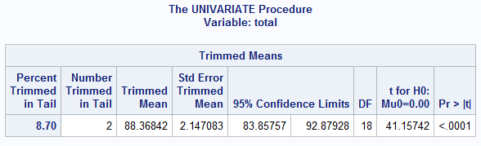

7

libname college 'C:\Users\Samil\Desktop\Sem 1\Stats for programming\SAS 9.4';

options fmtsearch=(college.formats);

**proc** **print** data=college.college;

**run**;

Title 'College' ;

**proc** **means** data=college.college mean min max median nmiss n maxdec=**2** ;

class StudentID;

var ClassRank GPA;

output out = my_college_stat;

/*mean = ClassRank GPA

n = ClassRank GPA

nmiss = ClassRank GPA

median = ClassRank GPA;*/

**run**;

Title;

Log File:

834 libname college 'C:\Users\Samil\Desktop\Sem 1\Stats for programming\SAS 9.4';

NOTE: Libref COLLEGE was successfully assigned as follows:

Engine: V9

Physical Name: C:\Users\Samil\Desktop\Sem 1\Stats for programming\SAS 9.4

835 options fmtsearch=(college.formats);

836

837 proc print data=college.college;

838 run;

NOTE: There were 100 observations read from the data set COLLEGE.COLLEGE.

NOTE: PROCEDURE PRINT used (Total process time):

real time 0.16 seconds

cpu time 0.06 seconds

839

840 Title 'College' ;

841

842 proc means data=college.college mean min max median nmiss n maxdec=2 ;

843 class StudentID;

844 var ClassRank GPA;

845 output out = my_college_stat;

846 /*mean = ClassRank GPA

847 n = ClassRank GPA

848 nmiss = ClassRank GPA

849 median = ClassRank GPA;*/

850 run;

NOTE: There were 100 observations read from the data set COLLEGE.COLLEGE.

NOTE: The data set WORK.MY_COLLEGE_STAT has 505 observations and 6 variables.

NOTE: PROCEDURE MEANS used (Total process time):

real time 0.36 seconds

cpu time 0.17 seconds

851 Title;

Output:

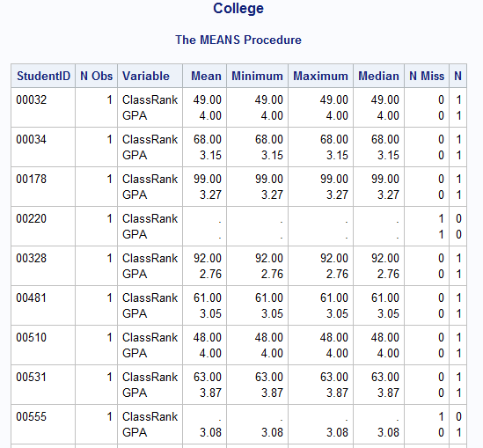

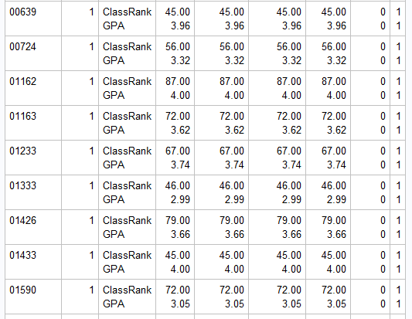

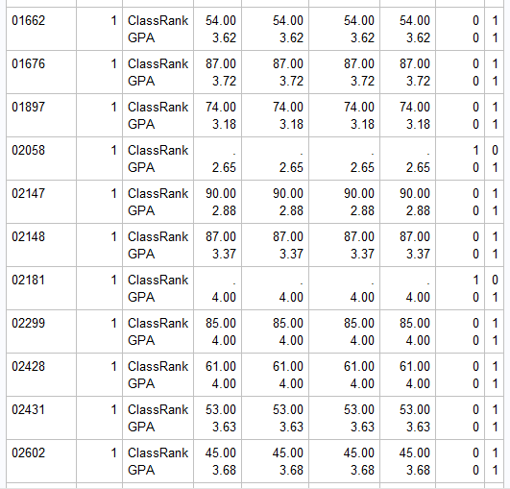

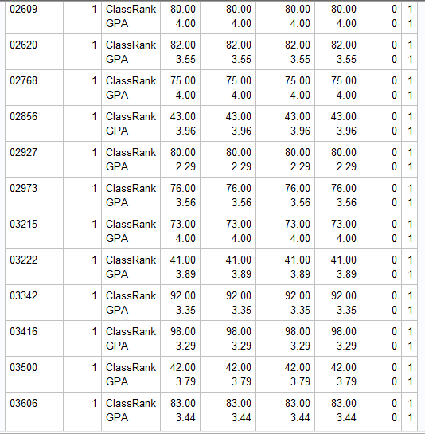

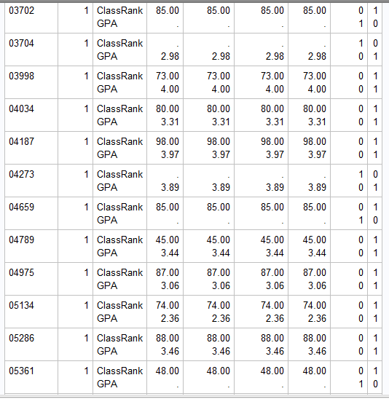

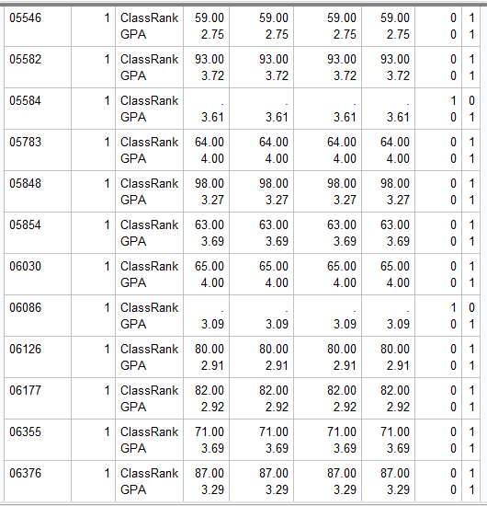

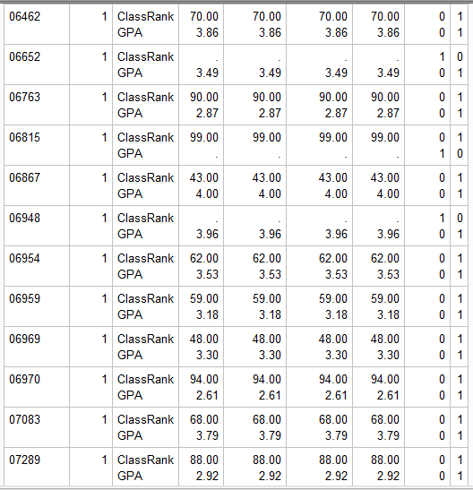

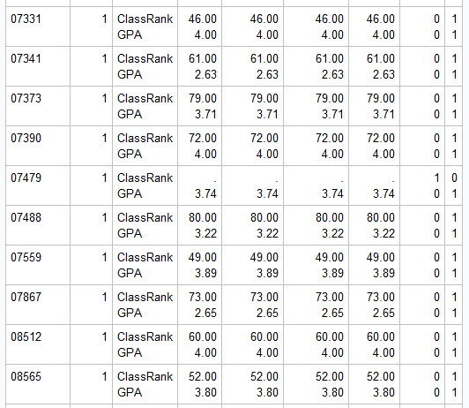

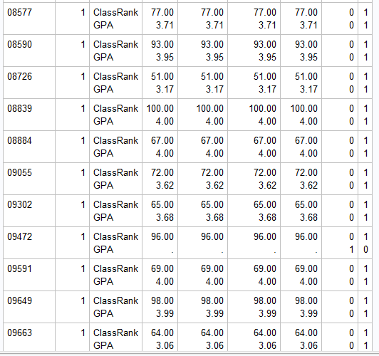

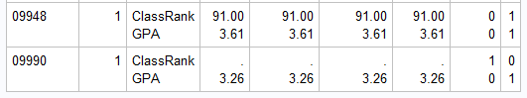

8

Code:

Title 'Class Method';

**proc** **means** data=college.college mean median missing maxdec=**2**;

class SchoolSize;

var ClassRank GPA;

output out = my_college_stat1;

/*mean = ClassRank GPA

median = ClassRank GPA;*/

**run**;

title;

**proc** **sort** data=college.college

out=my_college_stat2;

by SchoolSize;

**run**;

Title 'By Method';

**proc** **means** data=my_college_stat2 mean median maxdec=**2**;

by SchoolSize;

var ClassRank GPA;

output out = my_college_stat3;

/*mean = ClassRank GPA

median = ClassRank GPA; */

**run**;

Title;

Log File:

737 Title 'Class Method';

738 proc means data=college.college mean median missing maxdec=2;

739 class SchoolSize;

740 var ClassRank GPA;

741 output out = my_college_stat1;

742 /*mean = ClassRank GPA

743 median = ClassRank GPA;*/

744 run;

NOTE: There were 100 observations read from the data set COLLEGE.COLLEGE.

NOTE: The data set WORK.MY_COLLEGE_STAT1 has 25 observations and 6 variables.

NOTE: PROCEDURE MEANS used (Total process time):

real time 0.08 seconds

cpu time 0.03 seconds

745

746 title;

747 proc sort data=college.college

748 out=my_college_stat2;

749 by SchoolSize;

750 run;

NOTE: There were 100 observations read from the data set COLLEGE.COLLEGE.

NOTE: The data set WORK.MY_COLLEGE_STAT2 has 100 observations and 6 variables.

NOTE: PROCEDURE SORT used (Total process time):

real time 0.01 seconds

cpu time 0.00 seconds

751

752 Title 'By Method';

753 proc means data=my_college_stat2 mean median maxdec=2;

754 by SchoolSize;

755 var ClassRank GPA;

756 output out = my_college_stat3;

757 /*mean = ClassRank GPA

758 median = ClassRank GPA; */

759 run;

NOTE: There were 100 observations read from the data set WORK.MY_COLLEGE_STAT2.

NOTE: The data set WORK.MY_COLLEGE_STAT3 has 20 observations and 6 variables.

NOTE: PROCEDURE MEANS used (Total process time):

real time 0.16 seconds

cpu time 0.01 seconds

760

761 Title;

Output:

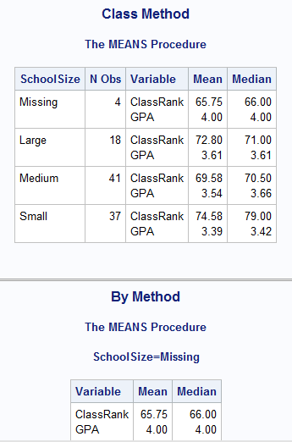

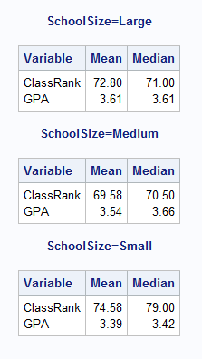

9

Code:

**proc** **format**;

value class_rank

**0**-**50** = 'Bottom Half'

**51**-**74** = '3rd Quartile'

**75**-**100** = 'Top Quarter';

**run**;

Title 'Mean by ClassRank';

**proc** **means** data=college.college mean maxdec=**2**;

class ClassRank;

var GPA;

format ClassRank class_rank.;

output out = my_college_stat4

mean = GPA;

**run**;

Title;

Log File:

762 proc format;

763 value class_rank

764 0-50 = 'Bottom Half'

765 51-74 = '3rd Quartile'

766 75-100 = 'Top Quarter';

NOTE: Format CLASS_RANK has been output.

767 run;

NOTE: PROCEDURE FORMAT used (Total process time):

real time 0.21 seconds

cpu time 0.00 seconds

768

769 Title 'Mean by ClassRank';

770

771 proc means data=college.college mean maxdec=2;

772 class ClassRank;

773 var GPA;

774 format ClassRank class_rank.;

775 output out = my_college_stat4

776 mean = GPA;

777 run;

NOTE: There were 100 observations read from the data set COLLEGE.COLLEGE.

NOTE: The data set WORK.MY_COLLEGE_STAT4 has 4 observations and 4 variables.

NOTE: PROCEDURE MEANS used (Total process time):

real time 0.18 seconds

cpu time 0.03 seconds

778

779 Title;

Output:

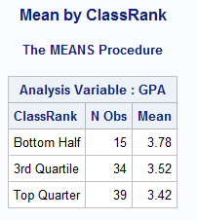

10

Code:

**proc** **means** data=college.college noprint nmiss max min chartype;

class Gender SchoolSize;

var ClassRank GPA;

output out = summary

mean =

nmiss=

max=

min=

n = / autoname;

**run**;

/*proc print data=summary;

run*/;

**data** grand(drop = Gender SchoolSize)

by_gender(drop = SchoolSize)

by_schoolsize(drop = Gender)

cellmeans;

set summary;

drop _type_;

rename _freq_ = Number;

if _type_ = '00' then output grand;

else if _type_ = '01' then output by_gender;

else if _type_ = '10' then output by_schoolsize;

else if _type_ = '11' then output cellmeans;

**run**;

title "Statistics Grand";

**proc** **print** data=summary (drop = _freq_);

where _type_ = '00';

**run**;

Title;

title "Statistics Broken Down by Gender";

**proc** **print** data=summary (drop = _freq_);

where _type_ = '01';

**run**;

Title;

title "Statistics Broken Down by Schoolsize";

**proc** **print** data=summary (drop = _freq_);

where _type_ = '10';

**run**;

Title;

title "Statistics Cellmeans";

**proc** **print** data=summary (drop = _freq_);

where _type_ = '11';

**run**;

Title;

Log File:

780 proc means data=college.college noprint nmiss max min chartype;

781 class Gender SchoolSize;

782 var ClassRank GPA;

783 output out = summary

784 mean =

785 nmiss=

786 max=

787 min=

788 n = / autoname;

789 run;

NOTE: There were 100 observations read from the data set COLLEGE.COLLEGE.

NOTE: The data set WORK.SUMMARY has 12 observations and 14 variables.

NOTE: PROCEDURE MEANS used (Total process time):

real time 0.08 seconds

cpu time 0.03 seconds

790

791 /*proc print data=summary;

792 run*/;

793

794 data grand(drop = Gender SchoolSize)

795 by_gender(drop = SchoolSize)

796 by_schoolsize(drop = Gender)

797 cellmeans;

798 set summary;

799 drop _type_;

800 rename _freq_ = Number;

801 if _type_ = '00' then output grand;

802 else if _type_ = '01' then output by_gender;

803 else if _type_ = '10' then output by_schoolsize;

804 else if _type_ = '11' then output cellmeans;

805 run;

NOTE: There were 12 observations read from the data set WORK.SUMMARY.

NOTE: The data set WORK.GRAND has 1 observations and 11 variables.

NOTE: The data set WORK.BY_GENDER has 3 observations and 12 variables.

NOTE: The data set WORK.BY_SCHOOLSIZE has 2 observations and 12 variables.

NOTE: The data set WORK.CELLMEANS has 6 observations and 13 variables.

NOTE: DATA statement used (Total process time):

real time 0.17 seconds

cpu time 0.03 seconds

806

807 title "Statistics Grand";

808 proc print data=summary (drop = _freq_);

809 where _type_ = '00';

810 run;

NOTE: There were 1 observations read from the data set WORK.SUMMARY.

WHERE _type_='00';

NOTE: PROCEDURE PRINT used (Total process time):

real time 0.29 seconds

cpu time 0.01 seconds

811

812 Title;

813

814 title "Statistics Broken Down by Gender";

815 proc print data=summary (drop = _freq_);

816 where _type_ = '01';

817 run;

NOTE: There were 3 observations read from the data set WORK.SUMMARY.

WHERE _type_='01';

NOTE: PROCEDURE PRINT used (Total process time):

real time 0.27 seconds

cpu time 0.03 seconds

818

819 Title;

820

821 title "Statistics Broken Down by Schoolsize";

822 proc print data=summary (drop = _freq_);

823 where _type_ = '10';

824 run;

NOTE: There were 2 observations read from the data set WORK.SUMMARY.

WHERE _type_='10';

NOTE: PROCEDURE PRINT used (Total process time):

real time 0.12 seconds

cpu time 0.06 seconds

825

826 Title;

827

828 title "Statistics Cellmeans";

829 proc print data=summary (drop = _freq_);

830 where _type_ = '11';

831 run;

NOTE: There were 6 observations read from the data set WORK.SUMMARY.

WHERE _type_='11';

NOTE: PROCEDURE PRINT used (Total process time):

real time 0.12 seconds

cpu time 0.04 seconds

832

833 Title;

Output:

